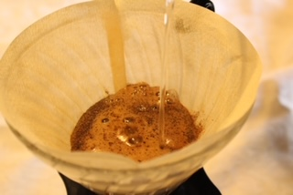
Third Wave Coffee

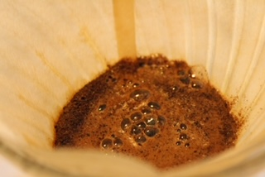

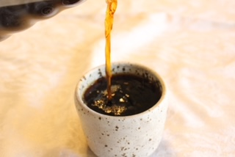

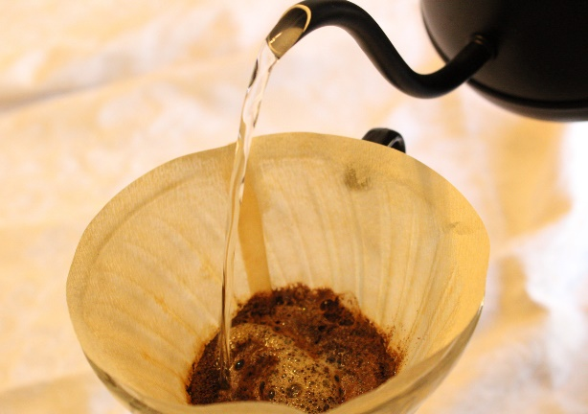
Introduction
When was the last time you took a moment to enjoy the quiet, simple moments that life offers? Likely, only a few instances come to mind, if any. Your answer displays the constant stimulation that the United States left its population desiring. However, over the past two and a half decades, the population has recognized these beautiful moments more often and slowed down to experience them. This ritualization movement began with coffee.
Coffee has fueled the world for hundreds of years, from Ethiopia, from where its roots and ritualization span, to the U.K. and Italy, where coffee bars began. Eventually, it made its way to the United States where in less than a century, people have made hundreds of advances in flavor, brewing and packaging technology, and relationships along the supply chain. Though the literal and social climate of coffee and the world have changed, the people who originated this journey in Ethiopia understood what we, as Americans, are only now beginning to grasp. Possibly, the best example is the Ethiopian Coffee Ceremony, a regular social and ritual occasion that blends all the best aspects of coffee: the gathering of people, slow brewing, and the enjoyment of the finished product. This is what the U.S. attempts to mimic in a movement called the “Third Wave” of coffee.
The First Wave
Post World War II, the “First Wave” was the movement that birthed household names like Folgers and Maxwell House, who sought to mass distribute “ready-for-the-pot” coffee. These companies made coffee available for everyone. In the process, they compromised quality and farmers’ working conditions.
The Second Wave
After the First Wave made coffee a household staple, the “Second Wave” sought to move it to the workplace. In fast-paced America, this created coffee giants Starbucks and Peet’s Coffee.⁶ While the qualities of both coffee and farmers’ working conditions improved, the desire for quick caffeine also increased. In this era, coffee shops became the middleman between work and home, replacing diners, taverns, and bars.⁷ Though better than the First Wave, the quality of drink decreased as these companies sizes grew. Essentially, the Second Wave caffeinated increasingly impatient consumers, creating a vicious cycle of supply and demand, sacrificing quality as a result.
The Third Wave
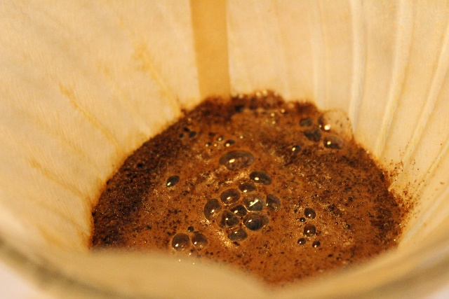
The Third Wave pursued success where the first two fell short. It slowly brought back the ritualization of coffee and created an inherently American experience in many privately owned shops. The “big brand” coffee shops coming out of this wave have become recognizable due to their prioritizing the coffee quality, flavor, and baristas. Some of these companies include Cat and Cloud, Counter Culture, and Stumptown, each of which boasts single origin and blended coffees for their individual characteristics. Shop owners and managers have aimed to flood coffee shops with ambience and a sense of belonging, making each visit a unique experience, not a meaningless encounter.

Before you go any further, keep in mind that not all privately owned shops are Third Wave, because it truly comes down to the individual philosophies of each shop and/or company. Mirroring rising cultural trends, the Third Wave combines tradition with innovation, greater awareness of trade problems, and heightened exposure of different brewing methods.⁸
The Farmer
The largest evolving issue involved with coffee is the unfair trade and working conditions the farmers endure. Since the beginning of large-scale coffee production, farmers were impoverished or enslaved people who depended on their field’s production to live.⁹ Companies took advantage of this need, so as the corporations grew, so did the quota. The farmers, plants, and soils suffered as a result. After years of hardship, today there are still hundreds of farmers who are underpaid and exploited.¹⁰
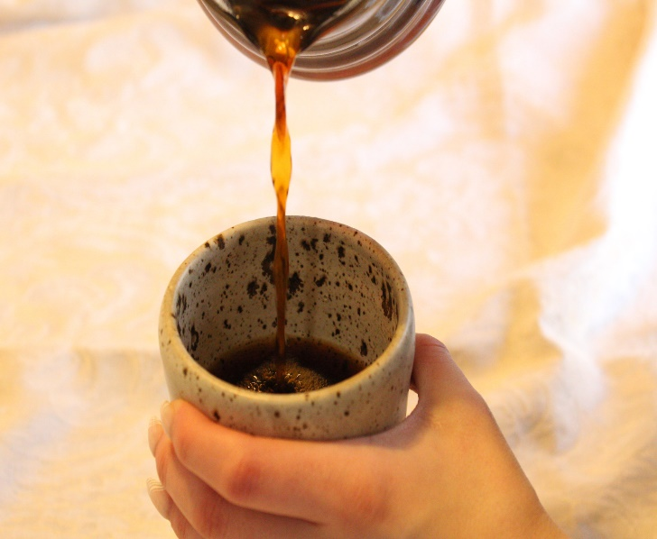
The Third Wave has attempted to repair this damaged relationship between those who purchase and grow by creating a green buyer¹¹ position. If a coffee roaster practices their craft socially and meritoriously, they will send a person, the green buyer, to the origin farm(s) to understand farmers’ work, form a partnership, and agree upon a price for the coffee. Both parties benefit in this situation because two people, divided by cultures and priorities, form an understanding of each other. Occasionally, due to presence or lack of contract, shops can breach the agreement if the farm is not meeting a quotient or pests take over crops, for example. So, while the Third Wave has mostly benefited farmers, and enriched consumers’ and roasters’ lives, independent variables, such as changing climate, can cause serious issues for the supply chain.
The Shop
With roots tracing back to Italy¹², coffee shops were originally created as a quick stop to sip on espresso. American shops did not become prominent, or develop their current culture, until the Second Wave, when coffee entered the workplace. As time passed, both shop owners and consumers desired more from their cup and as a result, the culture and drink developed. The most recognizable shop that displays this cultural development is Starbucks.¹³ It exemplifies how coffee became sacred in these social havens. The Third Wave shifted coffee culture in cafés by redirecting its focus and purpose to enhancing what Ethiopia began while simultaneously utilizing American innovations.
The Consumer
The center of the coffee world, economically, socially, and culturally, is the consumer. While they are influenced by the world around them, they influence the popular origins, roasts, and cup size. The First Wave marked the widespread availability of coffee.¹⁴ People everywhere were introduced to this luxury and only knew the incinerated, stale taste they were handed. Many people were still new to air travel¹⁵ and were not culturally aware of coffee’s uses. The Second Wave allowed people to understand how quality can match quantity, that coffee does not have one flavor, and is just as good at work as it is at home. While each wave sought to dig deeper in to the bean’s Ethiopian origins¹⁶ and the shops from Europe,¹⁷ the third one encompasses all the progress the United States made in the first two, with further innovation and ties to tradition.
The consumers are now seeking to catch even a glimpse of why people, countries away, will sit for hours, to create this drink from scratch. They desire this ritualization because in the U.S., business is idolized. People are burnt out from the fast-paced culture and are searching for the true essence of life in the small, quiet moments.

The Wandering Cup
The Wandering Cup, a coffee shop located in North Carolina, creates treasured moments inspired by the beauty of traveling the world. This special space inspires “wanderers” from near and far to understand world’s traditions, with the inherently American innovation. I had the honor of interviewing the owner, Melanie McIntyre, about how the waves of coffee have affected her shop.
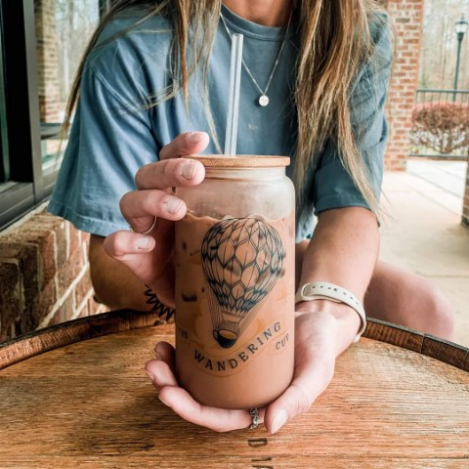
How has traveling influenced your coffee shop?
“I think it influenced my palette. Because of the amount of coffee shops I’ve visited, and the different kinds of coffee I’ve tried. So, I think they have sort of developed my palette over the years … Its also made me appreciate the coffee community and understand what it means to be part of it and see the camaraderie.”
Because of the influence travel has (on the shop), what experience do you hope customers receive?
“I always say that we want everyone to leave better than they came in. Whether that’s a great conversation or smile. I always find myself in conversations about travel … I think people just love the humanness of us. I just try to be genuinely interested in our customers, especially if they mention travel.”

Does your shop have aspects that reach for traditional roots, while enhancing with American innovation?
“Yeah, I mean there’s always people who want their black coffee. Then there are the people who just like super sweet stuff, but I think our seasonal menu is what sets up apart because we do try to think outside the box. I look at cocktail recipes a lot for inspiration and even Bath and Bodyworks candles to see things that go together that I’ve never thought of … I try to think of other ways to create a drink that isn’t adding more sugar but adding more flavor. So, then you can really create drinks with depth, with different layers, so that you can taste one thing at the beginning of the drink and you’re tasting something else at the end. And so just making it truly craft coffee.”
One last note
“As you talk about the waves, there are so many local and craft coffee places that are anti-Starbucks, and I am not one of those. I am grateful for Starbucks, because our shop would not exist without it. Starbucks brought the specialty coffee wave to America and made espresso more accessible. There was a time when people felt intimidated by coffee shops because of the ‘air’ surrounding them was snooty. Starbucks has educated so many consumers and so for people like me, I don’t have to do as much educating, because Starbucks Is already taking care of that.”

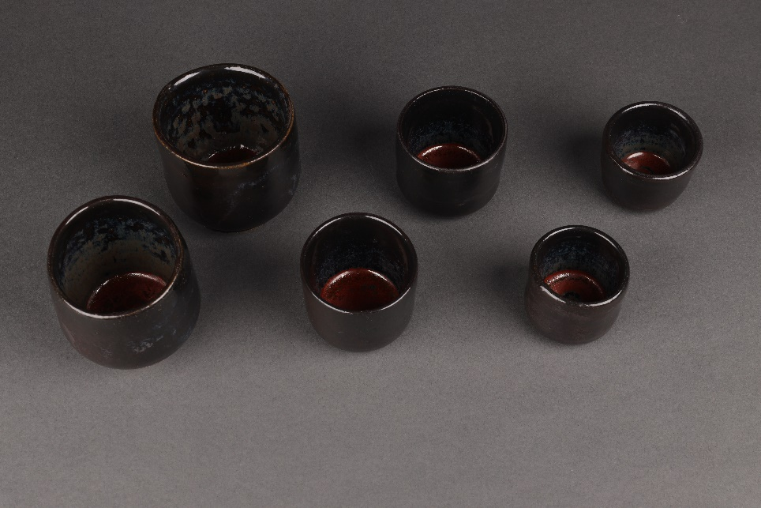
A note from the creator
Designing a year-long research project has been both the scariest and biggest accomplishment of my life. When fabricating, writing, interviewing, and designing this finished project, I had both my personality and the reader in mind. I want you to be able to get the most out of every word, on something visually appealing, with tangible elements that represent the traditions we hold close, combined with the newer trends we have come into. To represent this project further than words, I have created pairs of hand-thrown espresso, cortado, and cappuccino ceramic cups, measuring approximately 2.5, 3.5, and 6 ounces, signifying three of my favorite traditional drinks. I decided these cups would have a rounded bottom, with clean and defined feet, to keep a sleek, modern look. However, my favorite elements of this creation were the fact that they are handless. I always feel like the best way to connect with something is to get closer and truly feel it.

Endnotes

Sweeney, Shannon. “You Need an Exclusive Invite to Drink This Coffee.” Death
Wish Coffee Co., 2 December 2022, https://www.deathwishcoffee.com/blogs/news/ethiopian-coffee-ceremony
² “The History of Coffee.” National Coffee Association.
https://www.ncausa.org/About-Coffee/History-of-Coffee, Accessed 14 January 2023
³ Sweeney 2022
⁴ Mig. “History of Coffee: Its Origins and the Three Waves of Coffee.” Thrive
Coffee Roasters, 9 September 2020, https://www.thrivecoffeeroasters.co/history-of-coffee-its-origins-and-the-three-waves-of-coffee/
⁵ Mig 2020
⁶ Slocum, Katie. “From Farmlevel to Streetlevel.” Wordpress,
5 May 2015, https://streetleveltofarmlevel.wordpress.com/
⁷ Holden, Ronald. “Starbucks Gives Up On Its Evolution Fresh Concept.” Forbes,
23 February 2017, https://www.forbes.com/sites/ronaldholden/2017/02/23/starbucks-
gives-up-on-its-evolution-fresh-concept/?sh=421ea8de6ecd
⁸ Manzo, J. (2010). Coffee, Connoisseurship, and an Ethnomethodologically-
Informed Sociology of Taste.
Human Studies, 33(2/3), 141–155.
http://www.jstor.org/stable/40981129
⁹ Roman, Ivan. “6 Ways Coffee Helped Transform the World.” History,
11 March 2022, https://www.history.com/news/coffee-history-
facts#:~:text=Coffee&#39;s%20Globalization%20Helped%20Fuel%20Slavery,in%20their%20
far%2Dflung%20colonies.
¹⁰ Schiffman, Richard. “As Climate Changes, Colombia’s Small Coffee Farmers
Pay the Price.” Yale Environment360,
11 July 2019, https://e360.yale.edu/features/as-climate-changes-colombias-small-coffee-farmers-pay-the-price.
¹¹ Slocum 2015
¹² The History of Coffee
¹³ Holden 2017
⁴ Craft Beverage Jobs. “The History of First, Second, and Third Wave Coffee.”
Craft Beverage Jobs.
17 April 2016, https://www.craftbeveragejobs.com/the-history-of-first-second-and-third-wave-coffee-22315/

⁵ Smithsonian Institution. “The Evolution of the Commercial Flying
Experience.” Air and Space.
https://airandspace.si.edu/explore/stories/evolution-commercial-flying-experience, Accessed 3 March 2023
⁶ Sweeney 2022
⁷ The History of Coffee

Additional Resources

Anderson, Jack. “Why are Coffee Shops so Popular?” Esquires: The Organic
Coffee Co.
https://esquirescoffee.co.uk/news/why-coffee-shops-so-popular/, [Accessed October 29, 2022]
“Fair Trade vs. Direct Trade.” PBS, 7 May 2014,
https://www.pbs.org/food/features/lexicon-of-
sustainability-fair-trade-vs-direct-trade/
Guevara, Julio. “What is ‘Third Wave Coffee,’ & How is it different to Specialty
Coffee.” Perfect Daily Grind.
10 April 2017, https://perfectdailygrind.com/2017/04/what-is-third-wave-coffee-how-is-it-different-to-specialty/
“Interviewing.” Purdue University.
https://owl.purdue.edu/owl/research_and_citation/conducting_research/conducting_primary_research/interviewing.html, [Accessed Oct. 30, 2022]
McCabe, Kristen. “How to Create and Write a Case Study (+12 Great Example).”
G2.
25 March 2018, https://www.g2.com/articles/case-study
McIntyre, Melanie. Personal Interview. 23 January 2023.
Steele, Lindsay. “Measuring Items on the Pottery Wheel.” 31 January 2023,
Brightpoint Community College, Midlothian Campus, VA. Lecture Address.
11 July 2019, https://e360.yale.edu/features/as-climate-changes-colombias-small-coffee-farmers-pay-the-price

